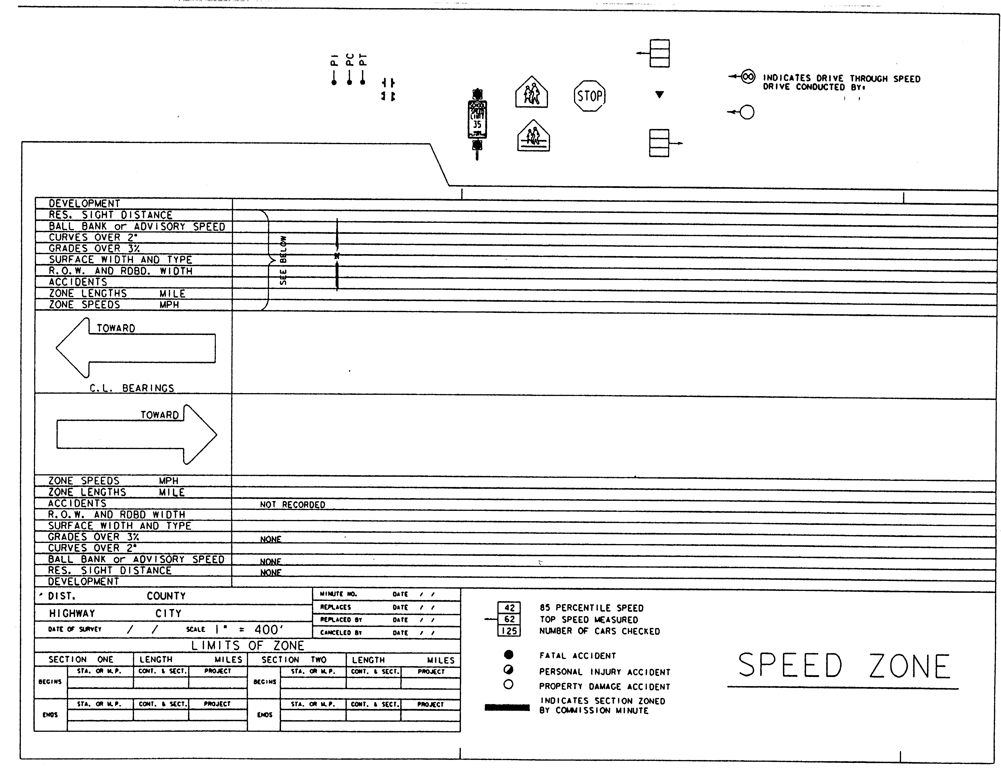
Figure 3-3. Strip map blank (reduced in size).

Procedures for Establishing Speed Zones / June 2005

