Chapter 3 – Speed Zone Studies Section 3 – Developing Strip Maps | 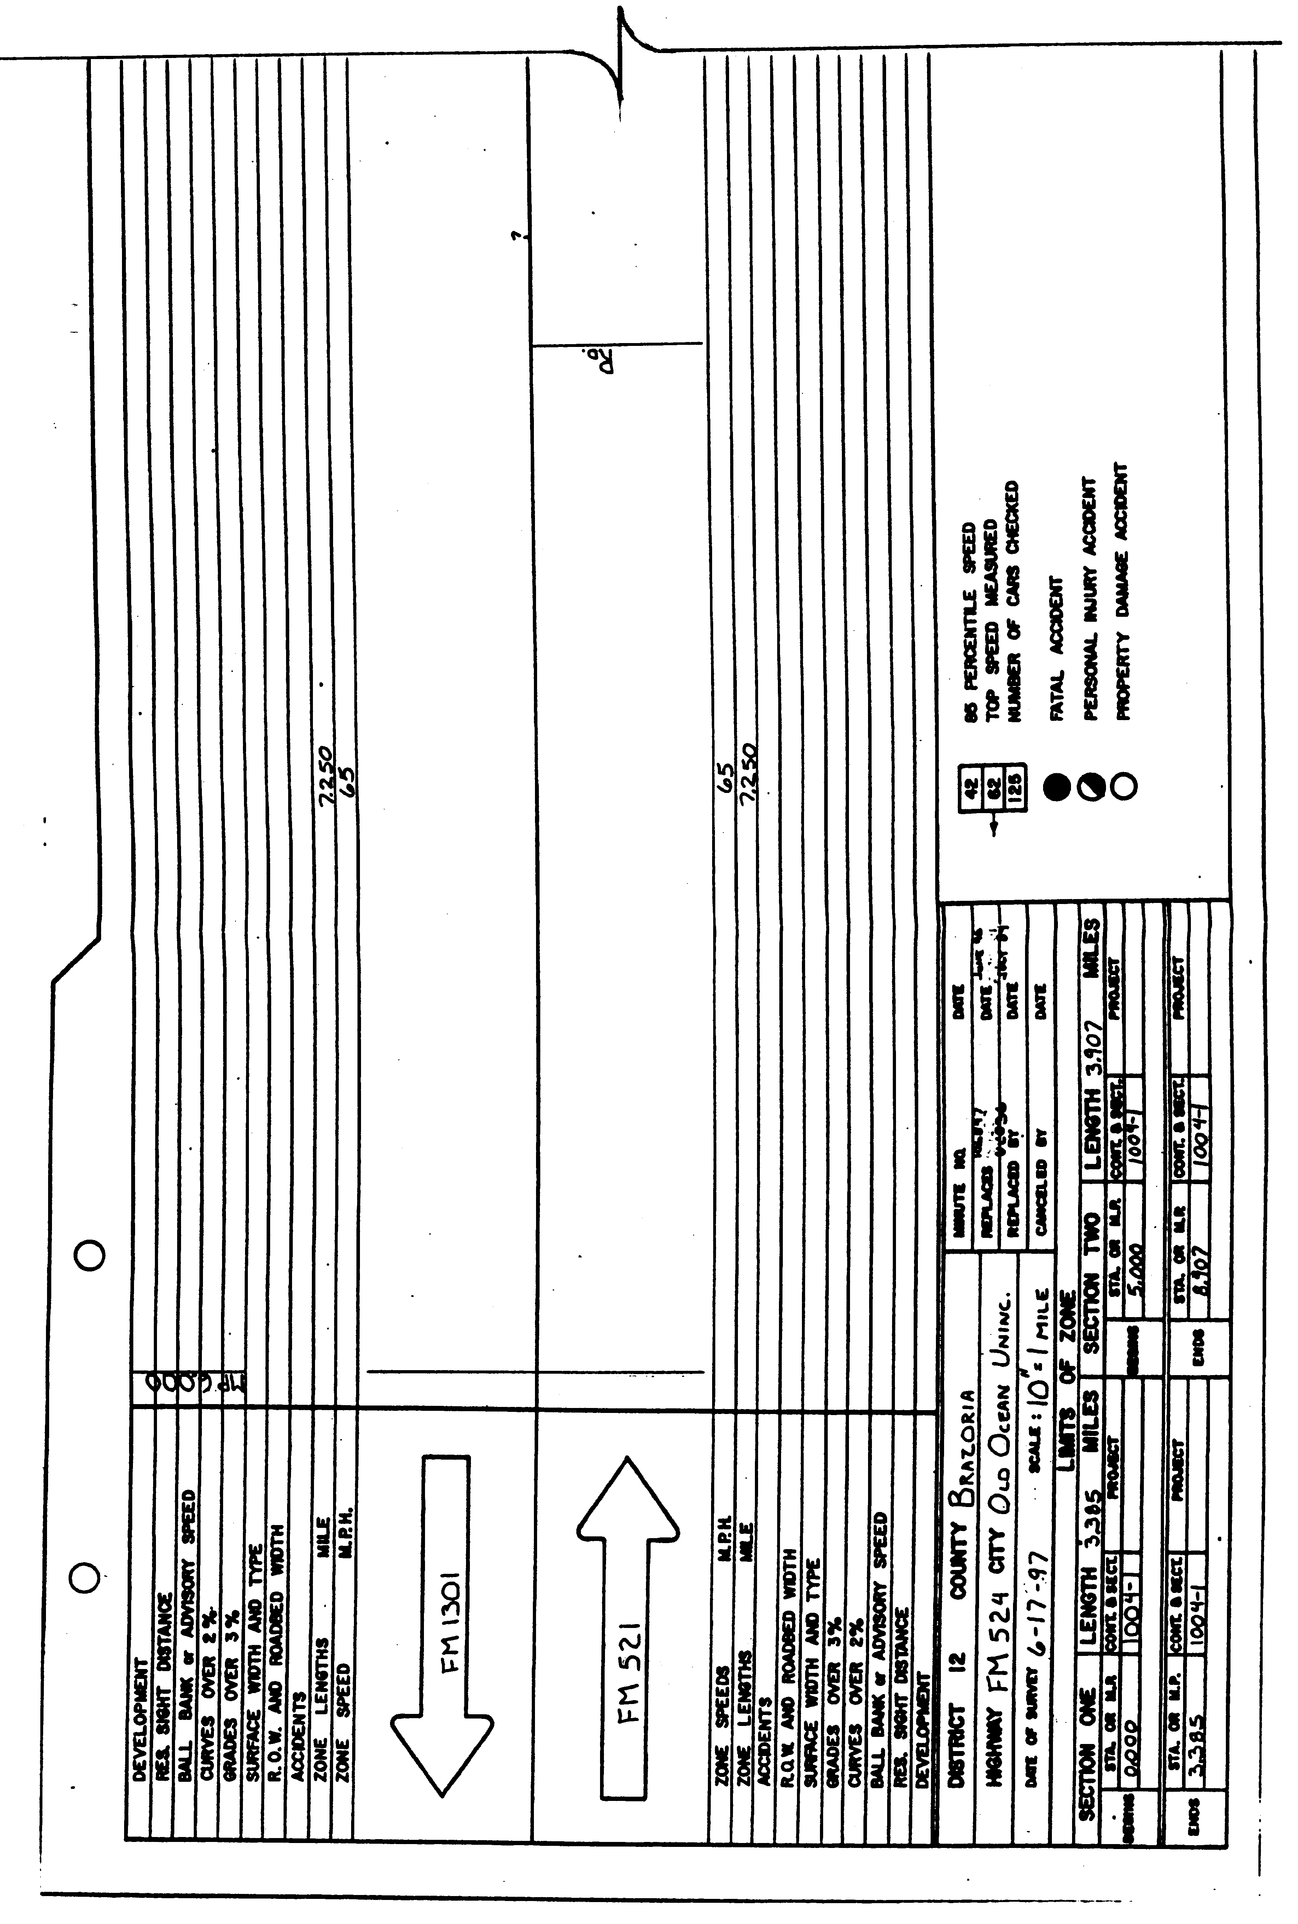 | Figure 3-5. Typical speed zone through an unincorporated community (continued in 3-6). | Procedures for Establishing Speed Zones TxDOT 10/97

Chapter 3 – Speed Zone Studies Section 3 – Developing Strip Maps | 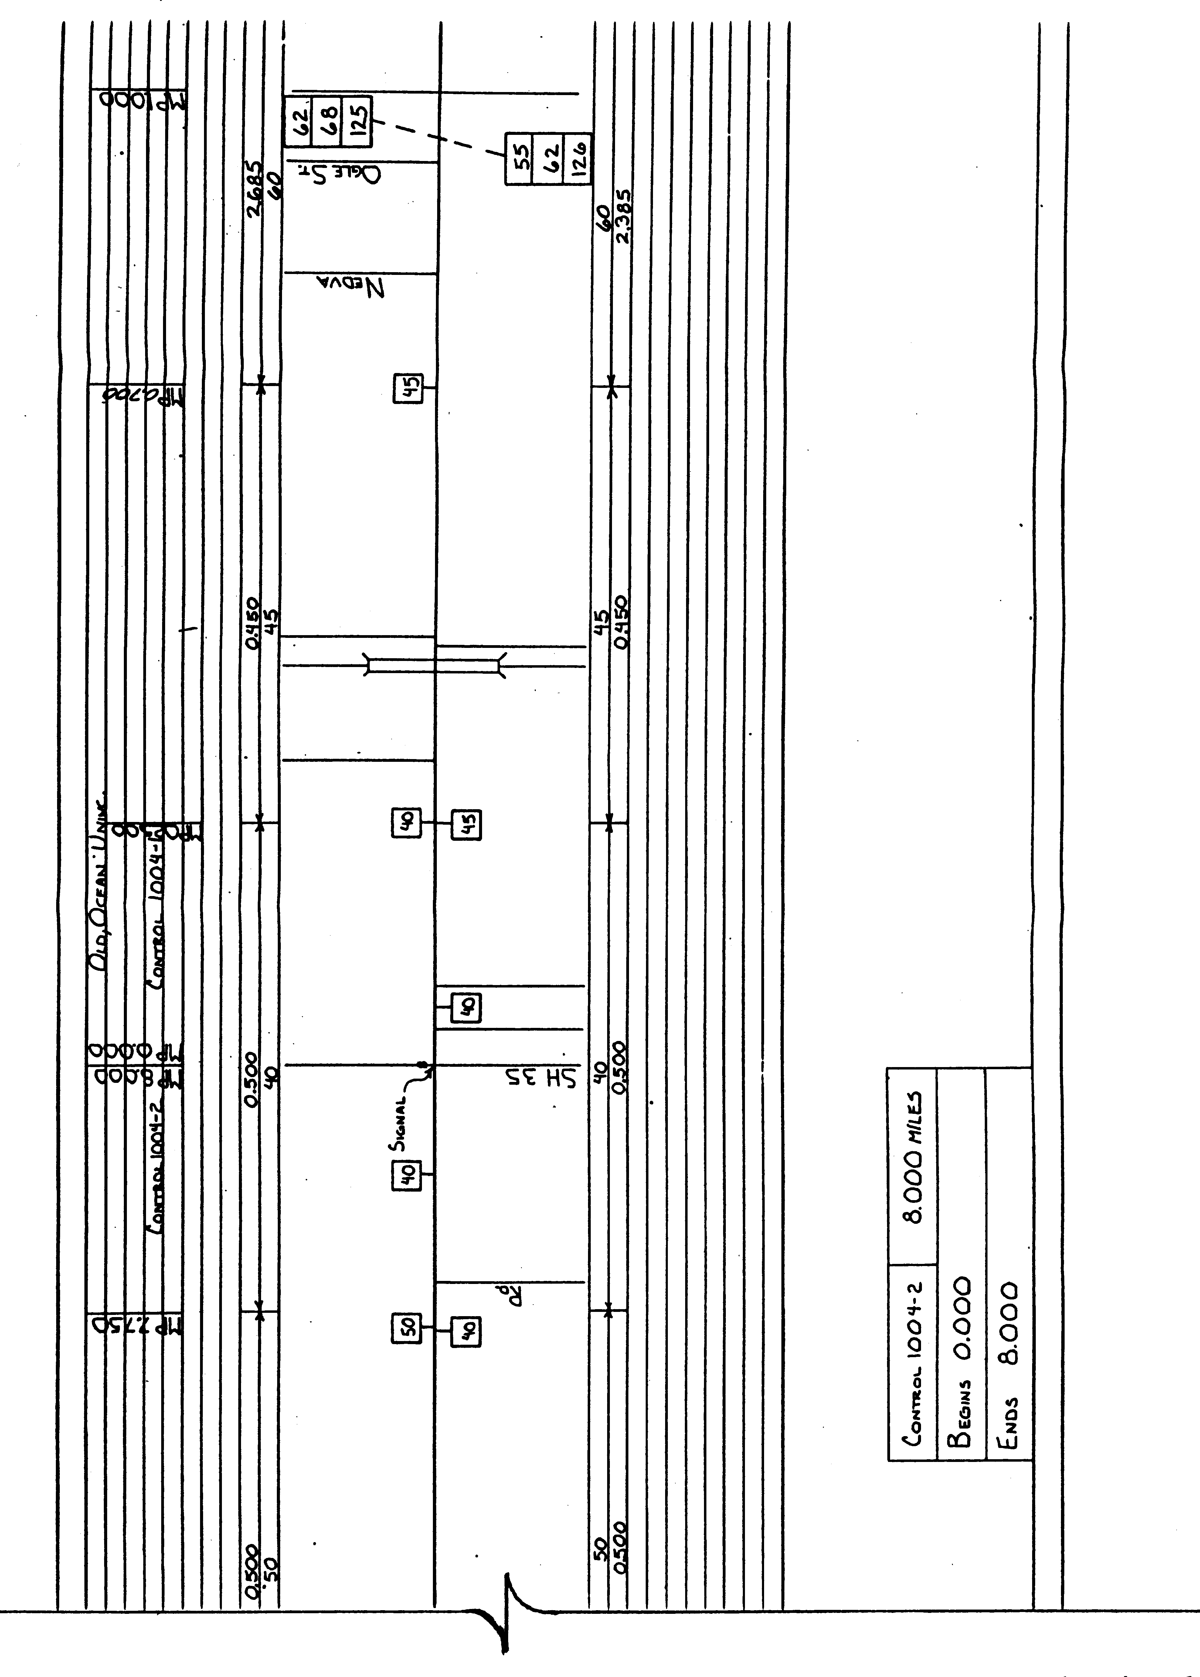 | Figure 3-6 (continued from Figure 3-5). Typical speed zone through an unincorporated community. | Procedures for Establishing Speed Zones TxDOT 10/97

